**11-16 notes**

Advanced Usage of the SQLalchemy ORM

Goals:

By the end of this lesson, you will be able to:

* Create classes that model tables by using the SQLAlchemy ORM.
* Perform CRUD operations on databases by using the SQLAlchemy ORM.
* Reflect existing databases.
* Review the table names in a database by using SQLAlchemy inspection.
* Plot query results that are retrieved by using SQLAlchemy.
* Run a t-test to validate differences in means.

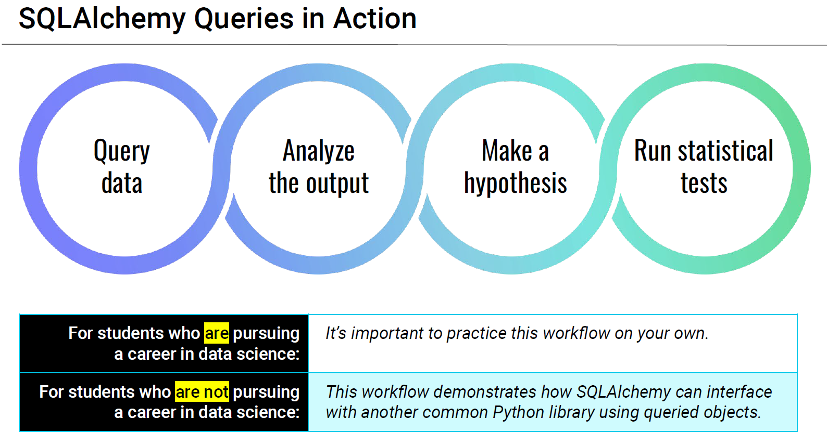

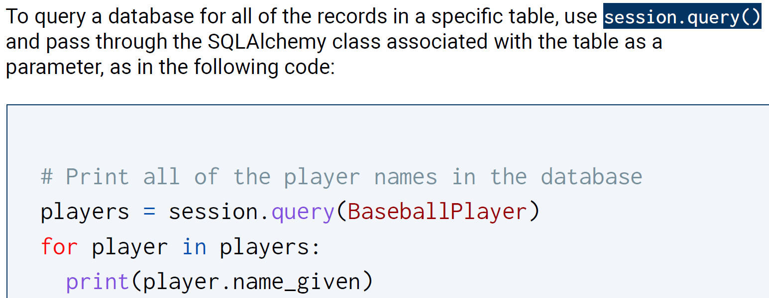

^ you are passing an object (a class, specifically), through this, not sql code

Using SQLalchemy:

Import dependencies

Base = declarative_base()

Make a connection

Make a session (object) to connect to database

Make a class (if necessary)

Query the database

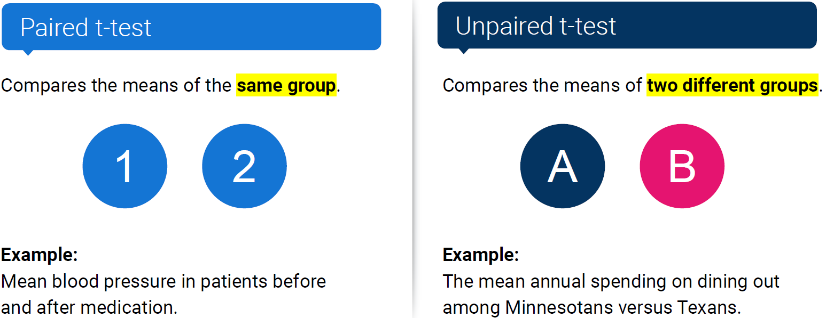

^ Paired t-tests use the same population, unpaired uses different populations

* Another example of where you’d use an unpaired t-test is people’s heights born before a certain year or after.

**Demographics solution:**

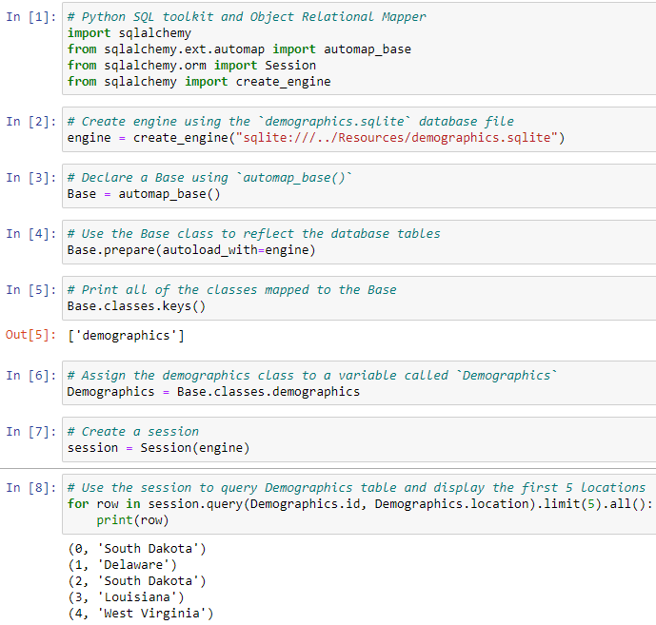

**Inspector tool:**

